The brain: structure and function

External structure of the brain:
Label the diagram:

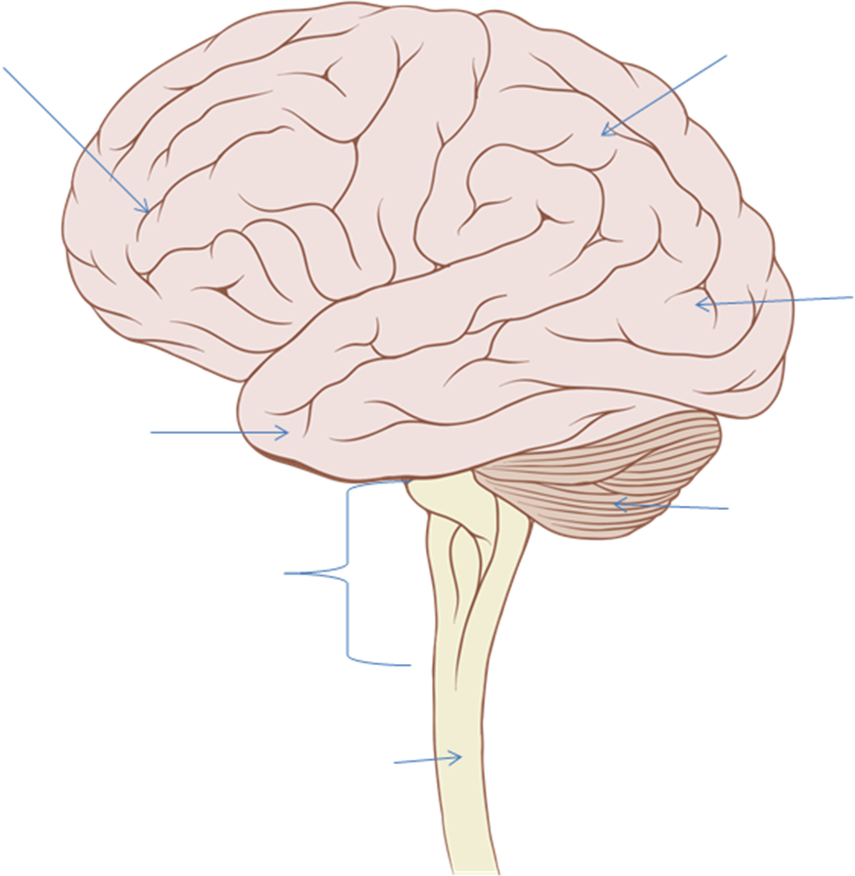
Labels:
Parietal lobe; occipital lobe; temporal lobe; frontal lobe; cerebellum; brain stem; spinal cord

Internal structure of the brain:
Label the diagram:

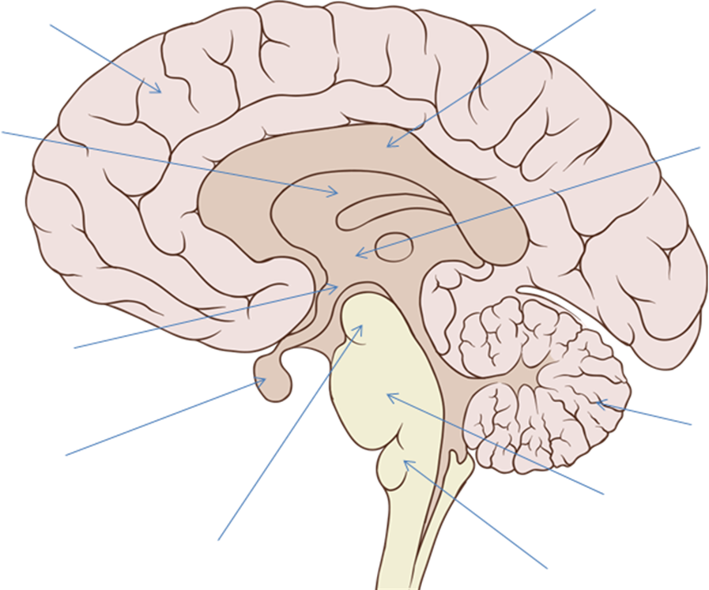

Labels:
Cerebral cortex; corpus collosum; cerebellum; hypothalamus; pituitary gland; mid brain; pons medulla oblongata

Functions of parts of the brain:

Structure | Function
Cerebral cortex
Cerebellum
Corpus collosum
Hypothalamus
Pituitary gland
Midbrain
Pons
Medulla oblongata

Explain how CT, MRI and fMRI scans enable scientists and doctors to look at the structure and functioning of the brain.
__________________________________________________
______________________________________________________________________________________________________________________________________________________________________________________________________________________________________________________________________________________________________________________________________________________________________________________________________________________________________________________________________________________________________________________________________________________________________________________________________________________________________________________________________________________________________________________________________________________________________________
Explain, with examples, how studies of brain damaged individuals have helped the study of brain function:
____________________________________________________________________________________________________________________________________________________________________________________________________________________________________________________________________________________________________________

